**Assignment 2 Template**

**LAST NAME: Lawson**

**FIRST NAME: John**

**USERID: jd2lawso**

**UWaterloo ID: 20466075**

**Problem 3:**

**population mean = 4.896**

**population standard deviation = 2.25858**

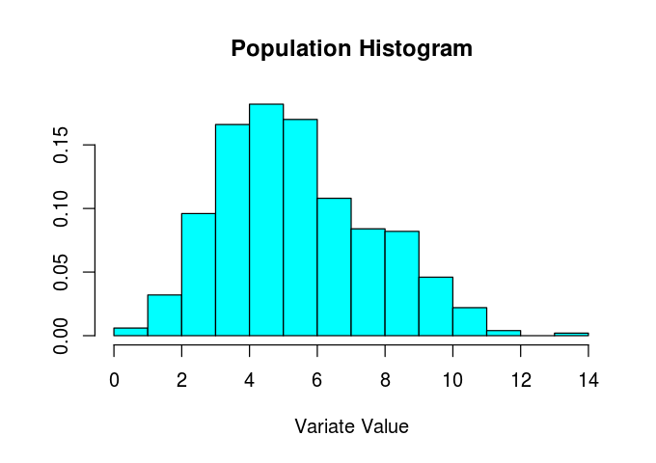

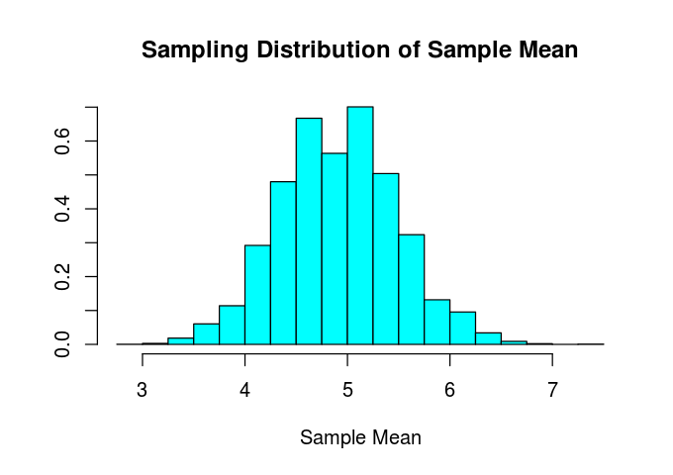

**What factor(s) affect the location of the sampling distribution of the sample mean?**

The location of the sample mean

**What factor(s) affect the spread of the sampling distribution of the sample mean?**

The variance of the dataset itself

**What factor(s) affect the shape of the sampling distribution of the sample mean?**

The variance of the dataset itself